REG NO: 221006043

DEPARTMENT: COMPUTER AND SOFTWARE ENGINEERING

MODULE: WEB TECHNOLOGY

DATE: 02/08/2022

PROJECT REPORT

1. Introduction
   1. **project summary**

online shopping has become very popular these days because people find it convenient and easy to shop from their home or office. People can save their time and energy by purchasing products online with some discounts. The offers on the internet can be easily compared, and the buyer can buy the product according to their favorable conditions like price, quality and other discounts for their individual needs. The next generation of mobile phone like smartphones has opened the new paths of using specially designed apps. We have most of the companies making use of this trend of getting their company products available on their website for sale, to be accessed via the app. They are also coming out with some great offers to attract customers to download and use their apps more rather than accessing their website.

* 1. **problem statement**

There are a lot of websites on the internet whereby it offers a variety of products and services for the consumer can find and buy online such as shoes, dresses, and so on. The online also provides some of the services which are paying bills online, booking a transport ticket, and more. In this research, we are looking at the problem addressed in this research which is the view of online shopping by consumers

* 1. **objectives**

the main objective of the inline shopping system is to manage the details of shopping and, internet, payments, bills, and customers. It manages all the information about shopping, products, customer, and shopping. The project is totally built at the administrative end and thus only the administrator is guaranteed the access.

* 1. **project rationale**

1. here are the benefits of virtual shopping for every shopaholic by proxy, the world’s first visual commerce platform. We have like;
2. **-increased convenience**
3. Visual shopping makes it easy for anyone to shop from anywhere without any restriction. There is no need of going out and get a parking space or waste time in traffic.
4. **-Enhanced customer service**
5. Virtual shopping makes it easier to ask for help, get solutions to issues, and find accurate information about the products and services you need.
6. -**Possibility to explore new products**
7. Virtual shopping makes it easier for people to try out new things because they do not need to ask for help from a salesperson
8. Methodologies and methods
   1. **data collection and**

**methodology**

this study was conducted using primary and secondary data. Secondary data were used to explore the motivating factors affecting consumers’ satisfaction to words online shopping. Source s were from the literature review from articles, journals, and different. Afterward, I summarized all those motivating factors as listed below in a questionnaire form to be used for primary data collection to investigate among respondents with the online shopping experience.

1. online shopping is time-saving you can purchase products or services after a few mouse clicks on your computer laptop, tablet, or phone cellphone.

2. online shopping saves energy because it requires less effort than going to traditional stores.

3. online shopping saves money because it offers better deals and products at reasonable prices without spending extra on transportation, fuel, or eating out.

4. comparison of prices is easy with online shopping.

**2.2.** **Tools to be used**

**-** Email marketing tool

-Website building tool

-Analysis and tracking tool

-Online payment tools

-Content filling tools

-Social media management tools

-Mail chimp

-Google Analytics

-Graphic river

-Ping Dom

-Last pass

-Google Drive

-Survey monkey

**2.2.1 hardware tools**

**-**claw hammer

-Adjustable wrench

-Multibit screwdriver

-folding hex key set

-pliers

-flash list

-tape measure

**2.2.2 software tools**

**-**claw hammer

-Adjustable wrench

-Multibit screwdriver

-folding hex key set

-pliers

-flash list

-tape measure

3. System analysis and design

**3.1. Requirements specification**

The online shopping system for wearing or dressing items shop web application is intended to provide complete solutions for vendors as well as customers through a single get way using the internet.

**3.1.1. Functional requirements**

-mobile responsive

-products attributes

-order and check out the flow

-social sharing

-usability

-security

-performance

**3.1.2. Data requirements**

Using expert standards is going to be crucial to ensure that you are giving your customers factual and detailed information and the more you do this the more your customers will see you as a reliable source to buy their automotive parts and accessories from

**3.1.3. User requirements**

**-**users should beable to use the e-commerce applicationfrom any web browser supporting HTML

-visitors new to the site should be able to register by themselves

-site visitors should be able to purchase goods or services via the electronics

**3.1.4 Security requirements**

-make sure you are buying from a real online address

-stay safe using a secure connection

-keep an eye on your bank account

-use antivirus protection for your pc

**3.1.5 Non-functional requirements**

-security

-usability

-performance

-maintainability

-scalability

**3.2. System design**

Due to technical and application levels, current online shopping is still in its infancy. Online shopping platform in the products display mainly based on the two-dimensional image and text information, which showed weak commodity performance, platform independent guide users pure interaction users weak shopping experience and shortcomings

**3.2.1. System overall architecture**

It allows client processes to run separately from the server processes on different computers. The client processes provide an interface for the customer that gathers and presents the data on the computer the customer**.**

**3.2.2. System information flow**

4. System implementations

**4.1. Landing page**

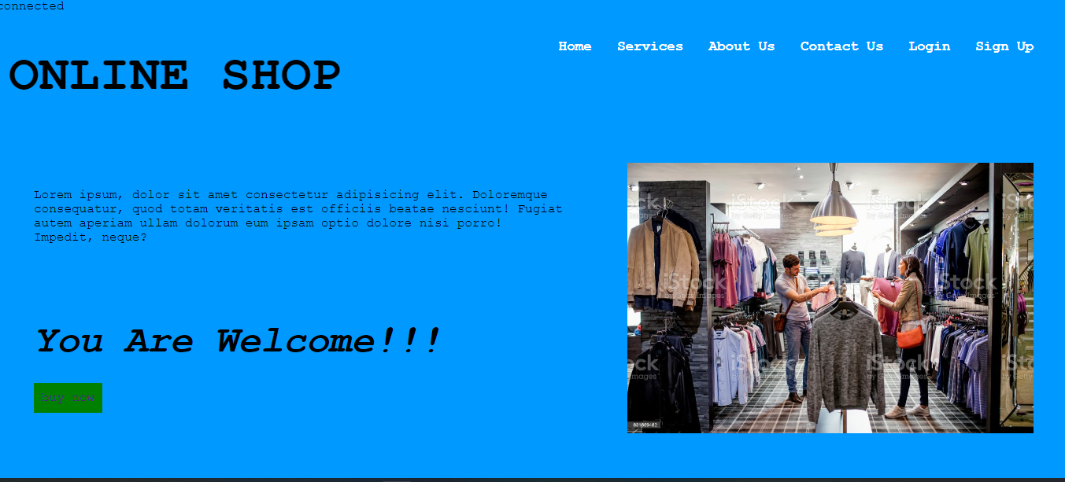

**4.2. Login page**

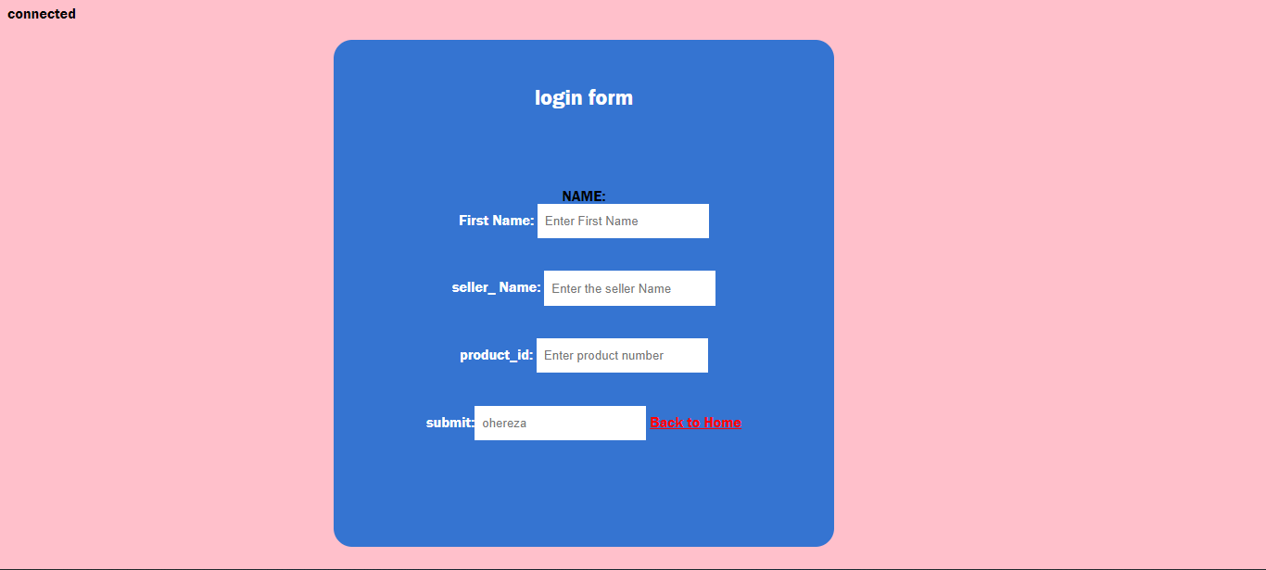

**4.3. contact page**

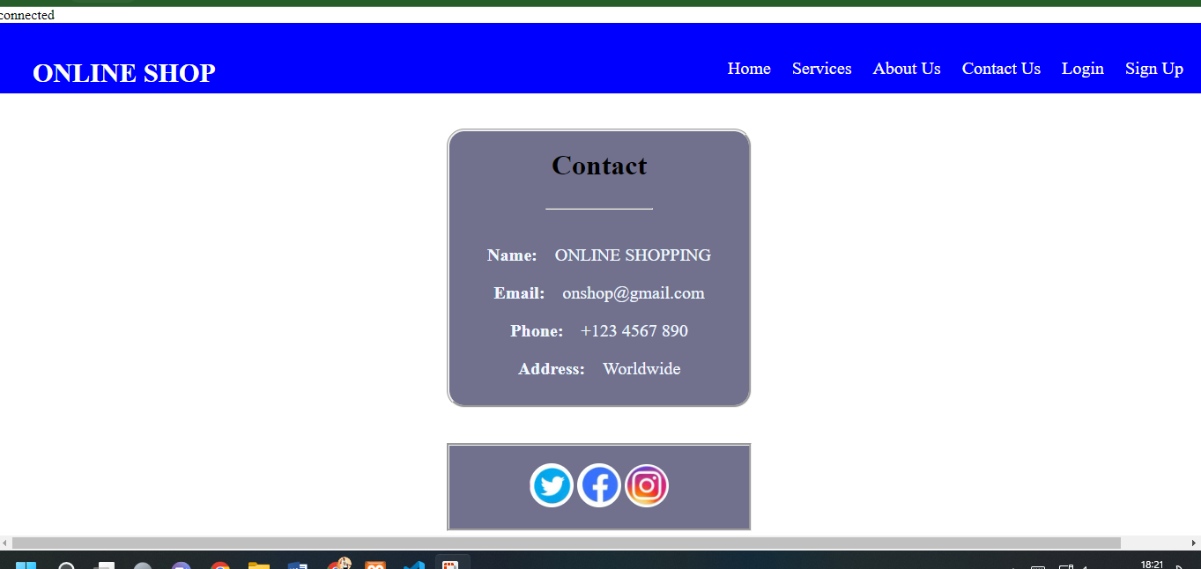

**4.4. sign up page**



**4.5. about us**

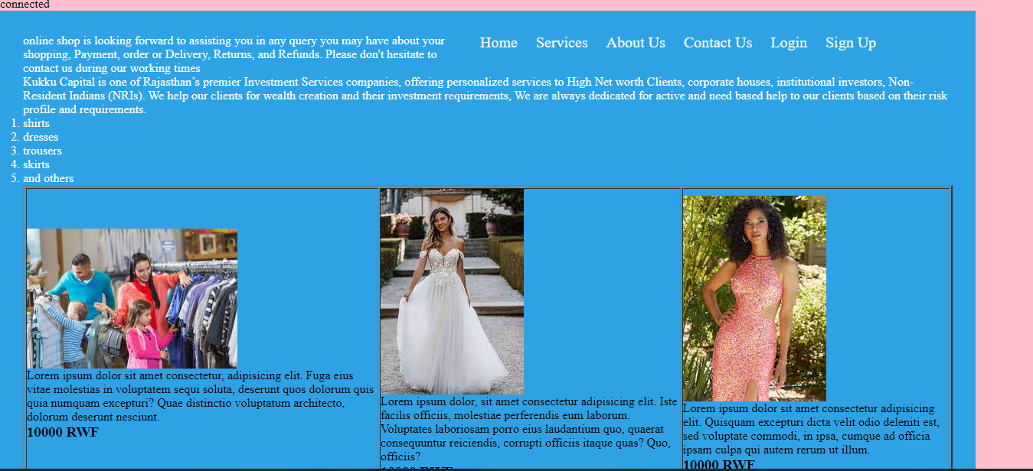

**5. Conclusion**

Technology has made significant progress over the years to provide consumers with a better online shopping experience and will continue to do so for years to come. With the rapid growth of products and brands, people have speculated that online shopping will overtake in-store shopping. While this has been the case in some areas, there is still demand brick-and-mortar stores in market areas where the consumer feels more comfortable seeing and touching the product being bought. However, the availability of online shopping has produced a more educated consumer that can shop around with relative ease without having to spend a large amount of time. In exchange, online shopping has opened up doors to many small retailers that would never be in business if they had to incur the high cost of owning a brick-and-mortar store. In the end, it has been a win situation for both consumers and sellers.

**6. Recommendation**

On this website, I have learned more about how the competitors are most likely a step or two ahead of me.

And also I learned about what my customers are thinking way ahead of my project.

Again I learned about what customers expect little short of perfection and also I must get educated on running an online shopping

**7. Appendix**